Robert Scott Katz

● ```Name: Robert Scott Katz

DOB: 1/24/1965

● Race: WHITE, CAUCASIAN, ASIATIC INDIAN, ARAB

Sex: MALE

Height: 5'6"

● Case #: 2D00365773

Case Type: CRIMINAL, DOCKET TYPE: SUMMONS

Category: CRIMINAL```

● Court: DISTRICT COURT FOR MONTGOMERY COUNTY - CRIMINAL SY

Court County: MONTGOMERY

Source: MARYLAND ADMINISTRATOR OF THE COURTS

● Offence Code: CR.8.609.(B)(1),CR.7.104,CR.8.609.(B)(3)

Offense Date: 11/15/2016

Offence Description: FORG-ORDER FOR MONEY,GOODS,THEFT: $1,000 TO UNDER $10,000,OBTAIN GOODS, MONEY-FORGERY

● **Address:** 11710 Old Georgetown Rd, Rockville, MD 20852

https://atlaspublicrecords.com/name/robert-s-katz/rockville-md/71981df0bf22

Summary:

Robert Scott Katz steals from the background and credentials of other people named Katz and claims he holds jobs like theirs, has education like theirs and in some cases has skills or accomplishments of theirs.

He makes uncorroborated claims of pioneering what became GPS tracking, internet email, autonomous vehicles, IoT, the whole internet, and the Mars Rover. He states that he has “captured” over 10 billion dollars in C5ISR contracts and that he himself has worked on projects for DHS, DOD, NIST, FEMA, Naval Postgraduate School, MIT, George Washington University, NRL, NASA, JHU/APL, CIA, NGA, FBI, DEA, NOAA, plus the Departments of State, Transportation, Justice, and Treasury. “For these, he often headed teams for major integrators, such as Booz Allen, Northrop Grumman, SAIC, and Lockheed Martin”, Hubble Space Telescope, Trident, Patriot, Iron Dome.

He belongs to 635 meetup groups and hundreds of LinkedIn groups, and has an unusually large number of very detailed testimonials on LinkedIn which we speculate have been written by paid freelance writers.

Multiple freelancers and graphic artists have sued him, created a Facebook page about his crimes, created a website stating that he is a con man, created GlassDoor reviews detailing the fraudulent experiences with Robert Scott Katz.

He claims to be a firefighter, EMT, a rescue diver, and claims to have gone to Israel to be trained to put out fires started by Hamas shelling, claims to have organized Urban Search and rescue (USAR) missions for Haiti. In a promotional video about himself, he is composited onto a stage with thousands of blue colored people watching him on a stage with one of his many dubious company logos projected hundreds of feet high around him. He poses for a moment in the video with a fireman’s pickaxe. He may have actually been a firefighter of some kind in Maryland at one time, or at least appears to be wearing a uniform and being interviewed on a news clip on YouTube, although he was nowhere near any kind of actual action.

His YouTube channel features firefighting and emergency / disaster diving news videos and he claims to have rescued people underwater but the links to news footage are not about him. He states that he is an “emergency medicine professor”.

Wikipedia has removed negative information posted about him, but also has removed multiple unverifiable claims he has made, pointing out that websites that run the bio he wrote have not verified what is in his bio. What remains on Wikipedia is sufficient for people who make a cursory check of him to believe some of what he says, leading to success at fooling his next victims.

He has at least $30,000 in civil judgements against him and an as yet undetermined number of constantly shifting company names and schemes. He appears to frequently attend cyber security related conferences and some of his schemes may have taken advantage of Asians who were part of or claimed to be part of a conference that Robert Scott Katz may or may not have actually held. He has found other people named Robert Katz with the middle initial S and uses some details from their life. Care is required when looking at any person to determine if you are looking at Robert Scott Katz born 1/24/1965 or a different Mr. Katz.

Untrue Claims of Inventions and Affiliations

**SOURCE:** “United States Cybersecurity Magazine” article which can be viewed here: https://en.calameo.com/read/0049064238204a87aaedf

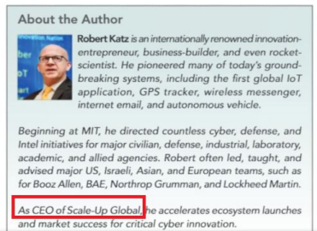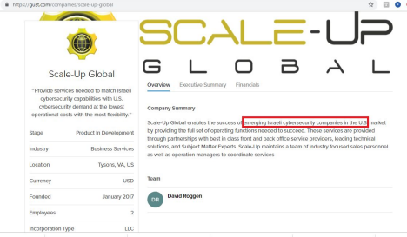https://gust.com/companies/scale-up-global

https://en.wikipedia.org/w/index.php?title=Robert_S._Katz&oldid=826121964

● His early work as an MIT rocket scientist included leadership of a Presidential Tiger Team to refocus components of the long-term Star War Strategic Missile Defense Initiative into an immediate, near-term theatre protection system. This work became THAAD, and later the Patriot, eventually becoming Iron Dome.

● Katz has lead numerous cyber, national, and homeland security-related C5ISR initiatives for the Pentagon, and its civilian, industry, laboratory, and academic partners. These include major projects for MIT, NRL, NASA, JHU/APL, FBI, DEA, DHS, ATFB, Marshal Service, US

Secret Service, NIST, NOAA, and the Departments of Defense, State, Transportation, Justice, Education, and Treasury, as well as for CIA, NGA, DIA, and other U.S. Intelligence Community members.

● Robert’s operational response roles include serving as a firefighter-paramedic responder and instructor, as a dive and swiftwater rescuer, and as an emergency medicine trainer. This includes supporting CONUS responses as well as for the Haiti Earthquake, Japan Tsunami, and the Nepal Earthquake..

Claims regarding rescue in Haiti

https://www.firehouse.com/home/news/11070176/in-times-of-disaster-neighbors-need-to-help-n eighbors-freeing-up-firefighters-and-ems-workers

Now Katz is an **Adjunct professor at George Washington University and helped organize Urban Search and rescue (USAR) in Haiti**..... "Firehouse Expo class presenter Robert S. Katz, an adviser for the Department of Defense, Department of Homeland Security, the Federal Emergency Management Agency, an adjunct professor at George Washington University and paramedic, taught a class on “MCI and Emergency Management: It Takes a Village.” "*Katz said he was pleased to be able to help organize Urban Search and Rescue (USAR) teams to deploy in Haiti"*

Claims regarding fire fighting in Israel

https://washingtonjewishweek.com/14851/grass-fire-diplomacy/news/world-news/ “The two men were part of a team of 12 American firefighters who headed to Israel for at least a week as part of the Emergency Volunteers Program, an Israeli nonprofit that recruits and trains emergency personnel in America to help when needed.

After learning Israeli firefighting techniques, Goldberg and Katz were thrust into action.

Whenever a siren went off, they rushed to the nearest shelter. “As soon as we got the all clear, or heard a bang, we started getting dressed” in their firefighting gear, Katz said. If a Hamas rocket landed in a grassy area, they had to put out the resulting brushfires, said Katz, explaining, “It’s very dry there.” Even rockets intercepted by the defensive **Iron Dome** system usually resulted in a brushfire from the resulting shrapnel, which “can cut trees in half,” Katz said.“

https://www.washingtontimes.com/news/2014/jul/16/us-firefighters-emergency-responders-volun teer-to-/

Katz claims to be a **teacher at University of Maryland ( is a Katz teaching there but not our guy)** and is the firefighter that went to Israel in this Washington Channel 4 piece

https://www.nbcwashington.com/news/local/Md-Firefighter-Teacher-Heads-to-Israel-to-Voluntee r-267251151.html (this news article has now been pulled by the news agency)

**Washington business journal**- **says he's an emergency medicine professor in this article + unbelievable myriad of credentials**

https://www.bizjournals.com/washington/promo/israel-tabach/rkatz

“Later, he went on to lead numerous cyber, national, and homeland security C4ISR initiatives for the Pentagon, and its civilian, industry, laboratory, and academic partners. These organizations include MIT, NRL, NASA, JHU/APL, CIA, NGA, FBI, DEA, DHS, NIST, NOAA, plus the Departments of State, Transportation, Justice, and Treasury. For these, he often headed teams for major integrators, such as Booz Allen, Northrop Grumman, SAIC, and Lockheed Martin.

His early cyber work pre-dates even the term “cyber,” including trailblazing contributions to Star Wars missile defense to ensuring network security, information assurance, jamming protection, and anti-spoofing for satellite sensors and missile interceptors. Additional cyber-space engagements involved securing the Hubble Space Telescope, Trident, Patriot, Iron Dome **(see page 14 for more info on this item)**, and multiple platforms for NASA, NOAA, Intelsat, and Inmarsat.”

Katz claimed to have been a **speaker for NSA Influence 2015**-conference below is link to all speakers and **Robert S. Katz** is **not on the speaker list** https://nsainfluence2015.sched.com/directory/speakers

https://www.emstoday.com/content/dam/Events/EMS/Documents/DisasterTerrorism/ICDTP2013 _Brochure.pdf - A bio for a conference in 2013 on pg 12.

(Katz did all this and is coming to DHS S&T expo as a member of the media??)

Robert S. Katz

is a homeland security consultant

by day, firefighter-paramedic by night. He has

led countless initiatives, including **multiple**

**assignments for MIT, NIST, Navy, NASA, DoD, State,**

**and UN missions focused on surveillance within**

**domestic and OCONUS theatres.**

Wikipedia Removals of Unverifiable Claims:

Next 2 pages are documentation of information removed from Robert S Katz Wikipedia paper because it could not be corroborated. According to his bio, used as a reference on his Wikipedia page: ● administrator (26 April 2016). "Robert Katz".

He *designed what became the first autonomous vehicle, the Mars Rover*.

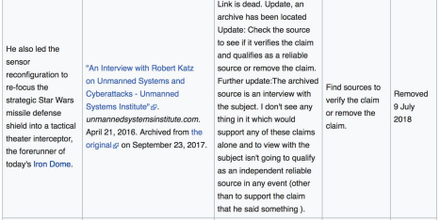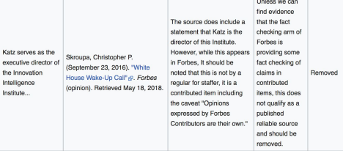

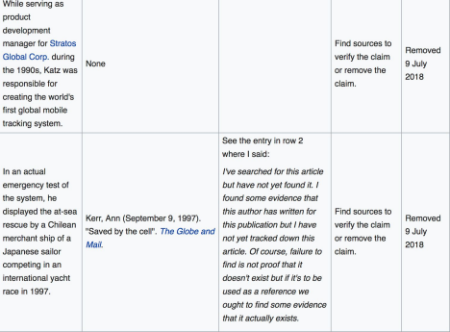

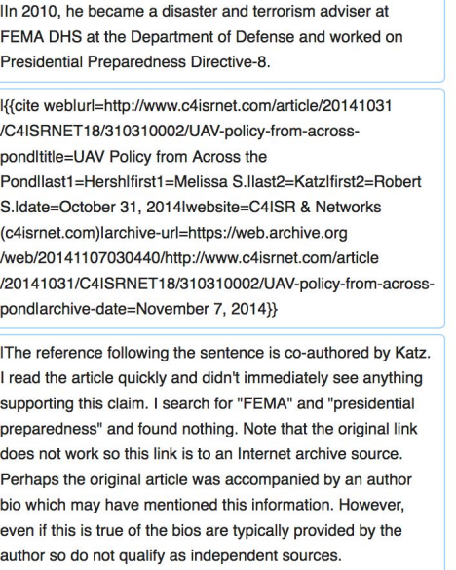

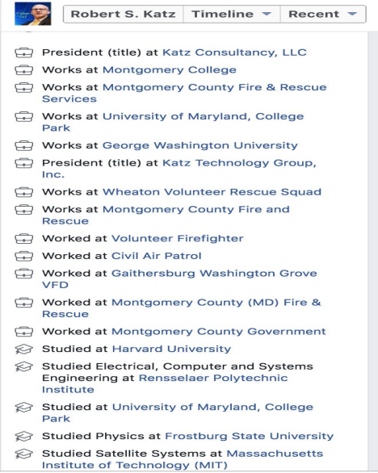**From Robert S. Katz Facebook page**

Legitimate: Jonathan Katz, Maryland Cybersecurity Center

False: Robert Scott Katz claims affiliation with UMD

Robert Scott Katz has lifted some of Jonathan Katz affiliations such as ManTech, Lockheed Martin and Northrop Grumman.

https://umdrightnow.umd.edu/news/katz-named-director-maryland-cybersecurity-center This is the Katz that works at the University of Maryland. **Robert S Katz falsely claims to work at University of Maryland on his facebook page.**

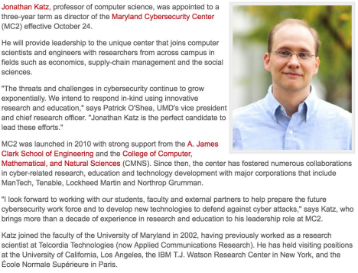

Legitimate: Robert S. Katz, a real GWU professor False: Robert Scott Katz claims to be Adjunct professor at GWU

Robert S Katz falsely claims to work at George Washington University (on his Facebook page) The only Robert S. Katz at George Washington University is a law professor and a lawyer at Banner & Witcoff, Ltd

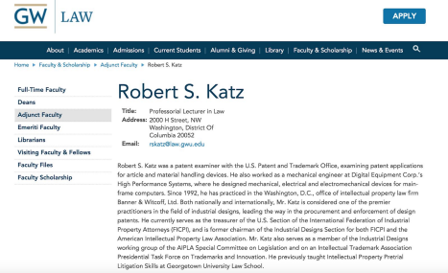

False claim: works at Montgomery College

Robert S. Katz falsely claims to work at Montgomery College (on his Facebook page) He is not listed in the college directory.

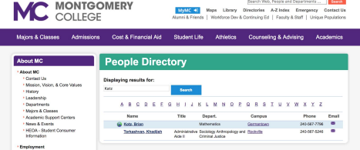

Maryland Judiciary Case Search

http://casesearch.courts.state.md.us/casesearch/inquiryByCaseNum.jis

Maryland Judiciary Case Search Results- Mostly for not paying contractors,creditors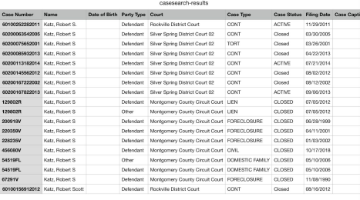

https://jportal.mdcourts.gov/judgment/judgementSearch.jsf

Robert S. Katz-judgements and Liens

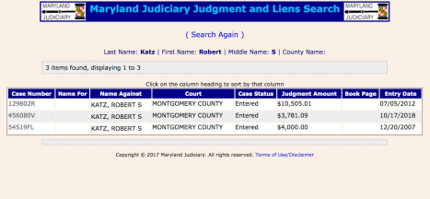

Scam Complaints from Unpaid Writers & Graphic Artists

**Robert S Katz company- Innovation Intelligence Institute**

Glassdoor has multiple reviews saying this man does not pay his contractors https://www.glassdoor.com/Reviews/Cyber-Science-Institute-Reviews-E1658927.htm

Here is a sample below

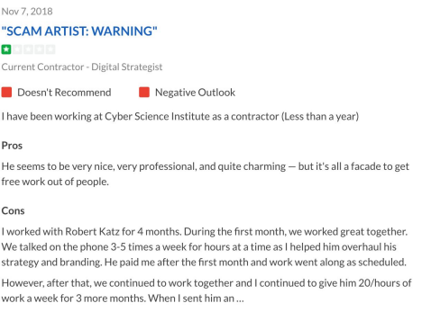

https://www.facebook.com/RobertS.KatzCrimes/- Facebook page created by people swindled by

Robert S. Katz

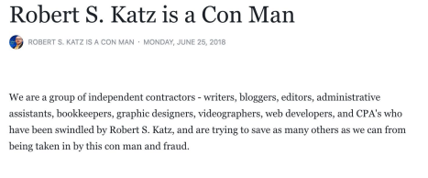

Advertisements for his Services

These represent a danger to future investors or customers of being scammed. Here is a tiny sample of the numerous companies, links and promotional moments he has created.

https://www.ebenefitsnetwork.com/robert-katz/

https://en.wikipedia.org/w/index.php?title=Robert_S._Katz&oldid=837865547 (Wikipedia prior to when many of his unsubstantiated claims were removed.)

https://www.meetup.com/Lean-Startup-in-the-Enterprise/members/50741902/ https://tmt.knect365.com/iot-world/speakers/robert-katz-2

https://www.linkedin.com/in/robertscottkatz/

https://twitter.com/Robert_Katz

https://www.youtube.com/user/RobertScottKatz

https://webcache.googleusercontent.com/search?q=cache:dzzd5LzcUOkJ:whartondcinnovation. com/speaker/robert-katz/+&cd=1&hl=en&ct=clnk&gl=us

https://en.calameo.com/read/0049064238204a87aaedf

Misleading Image and Video Artifacts

Some images and video include a creator name and email address. We proved a connection between Robert Scott Katz and Jeff Carpenter, such as:

http://www.glassrivermedia.com/our-work/

Go to 1minute 10secs in the video to see a familiar image of Robert Scott Katz. Jeff Carpenter may just be another victim of Robert Scott Katz. Katz having a track record of hiring graphic artists and not paying his bill in full.

|

xmp:CreatorTool="Adobe Photoshop Lightroom 6.2.1 (Macintosh)"```

| <rdf:li>Carpenter</rdf:li>

| <rdf:li xml:lang="x-default">jeff.redfeather@gmail.com</rdf:li> 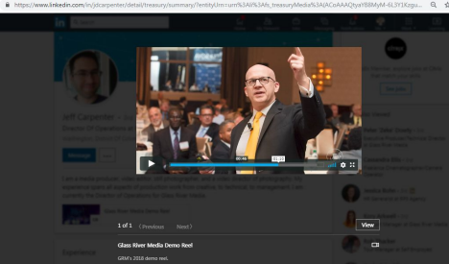

Every Picture of Robert “speaking” at a conference,Black suit, yellow tie, microphone on tie, object in right hand



http://alumni.rpi.edu/s/1225/alumni/index.aspx?sid=1225&gid=1&page_id=4744&pgid=253&cid= 645&ecid=10072&search=Robert+Katz

**False: Robert S. Katz claim in LinkedIn to have attended Rensselaer Polytechnic Institute 1986-1988**



**False: Robert S Katz claim in LinkedIn for 2010 Naval Postgraduate School Adjunct Faculty.**

search for Robert S Katz from 2009- 2011, yielding no results

**FALSE: Robert S Katz claim in LinkedIn that he attended MIT 1988-190 and that he did Postgraduate Research, Artificial Intelligence & Neural Nets for Autonomous Vehicle Navigation**

****Dean A Pomerleau actually did this research

(screenshot from google)

Asked a friend who’s sister went to MIT to check alumni site- “Hi, Just heard from my sister. She says that there was no Robert S. Katz listed (for any year) in the MIT alumni directory she checked on-line”.



**FALSE: Testimonial on Robert S Katz Linkedin Page. This conference was cancelled, yet Carlos White gives a glowing testimonial about Robert Katz’s talk.**



**LinkedIn Work Experience**

**Glassdoor has a different start date (1989) for Cyber Science Institute https://www.glassdoor.com/Overview/Working-at-Cyber-Science-Instit ute-EI_IE1658927.11,34.htm**



**When I look up website www.cysci I ended up at a website with a virtual office address: 200 Park Avenue, Suite 1700, New York, NY 10166 phone# 888-863-3423**



**FALSE LinkedIn work experience claim: Robert S Katz is not an Adjunct Professor at George Washington University.**

The

Robert S. Katz at George Washington University is a law professor and a lawyer at Banner & Witcoff, Ltd



**Ariel Katz bio from Geospatial Summit (links are all dead) http://geospatialsummit.com/events/2011/Speakers/Speaker%20Wind ow.aspx?SpeakerId=%7B454EA019-E259-457D-8C41-5F1DB9026610% 7D&ID=%7B25A4E92A-915C-43E8-A787-AAA81639118F%7D**



**https://presspage-production-content.s3.amazonaws.com/uploads/19 13/2011jultosepvolunteerpdf.pdf?10000**

**Civil Air Patrol publication from 2011 with story about Ariel Katz (pg 25). In the story the father Robert Katz is listed as being a consultant/working with Google and Carnegie Mellon.**

**\*\*\***

**Ari Katz states he got a BA in “International Studies” here, would need an alumnus to check:**

**https://alumniassociation.american.edu/s/1395/rd17/interior-2col.aspx ?sid=1395&gid=1&pgid=6&cid=41&contentbuilder=1&_ga=2.14203096 2.1998897433.1545059556-1336706230.1545059556#/Search/Simple**

**http://www.kolhabirah.com/index.php/topics-of-interest/young-profess ionals-spotlight/412-ari-katz**



In above article Ari says that John Travolta flew Ari to Haiti in Travolta’s private 707 jet, where they passed some time together on the tarmac discussing Travolta’s firefighter movie Ladder 49.

What can be verified is that Travolta flew his 707 to Haiti as there are multiple articles discussing this as well as the trackability of the id numbers for that plane. Travolta is said to have transported 6 tons of MRE as well as yellow-shirt Scientologist healers who touched people who had problems in the Hatian hospitals such as missing legs. There was controversy regarding the Scientologist visitors. So far what the results or activities of Travolta’s delivery to Haiti have not been found in news articles.

Ari was 27 at the time of this article, making him 13 when he started Civil Air Patrol. This is possible, due to the cadet program:

https://en.wikipedia.org/wiki/Civil_Air_Patrol

https://www.linkedin.com/in/arielmkatz/

Coocooforcoco.net Sister’s blog, seems not to exist anymore

https://www.linkedin.com/in/eliorakatz/detail/treasury/summary/

https://www.youtube.com/watch?v=VQz1Vzn6rrI audio on Robert Scott Katz youtube channel, his daughter Eliora is introduced as having a position in mayoral administrations in both Chicago and Jerusalem. The interview is on American Latino radio on sirius xm.

Mother of Eliora and Ari is https://www.pinterest.ru/tkmikaelian/, an Iranian lady who may be divorced from Robert Scott Katz.



12.jpg

Signature: 0155D875C95B74D0F3C5835A62516F48

Signature (Rotated): 01D38A25358EB7649A254E19F1D46600

10.jpg

Signature: 0155D875C95B74D0F3C5835A62516F48

Signature (Rotated): 01D38A25358EB7649A254E19F1D46600

1500x500.jpg

Signature: 0155D875C95B74D0F3C5835A62516F48

Signature (Rotated): 01D38A25358EB7649A254E19F1D46600

06.jpg

Signature: 0155D875C95B74D0F3C5835A62516F48

Signature (Rotated): 01D38A25358EB7649A254E19F1D46600

All photos were analyzed with JPEGSnoop with these four images all with the same signature, indicating all images were created on the same machine with the same piece of software. Images 06.jpg, 10.jpeg, and 12.jpeg were all downloaded directly from Glass River Media’s website. Image 1500x500.jpeg was download from Robert Katz Twitter page.



The domain listed on the subcontractor website is the same domain Robert Katz has listed on Linkedin (https://www.linkedin.com/company/innovation-intelligence-institute/about/) for an Cyber Science Institute by the same name. (Side Note: you will notice the Linkedin URL is the same one used with the defunct Innovation Intelligence Institute). The phsical address shown is a virtual office location

https://www.davincivirtual.com/loc/us/new-york/new-york-city-virtual-offices/facility-1382

When a Directory Listing lookup is performed on the phone number listed on the subcontractor site, the number comes back as being owned by Robert Alan Katz.

national_format: (301) 983-6700,

phone_number: 3019836700,

is_commercial: true,

associated_people:

name: Innovati Intelligence,

firstname: Innovati,

middlename: null,

lastname: Intelligence,

relation: PotentialOwner,

name: Robert Alan Katz,

firstname: Robert,

middlename: Alan,

lastname: Katz,

relation: PotentialOwner,

country_calling_code: 1,

belongs_to: [

age_range: null,

name: Catz Technology Group Inc, firstname: null,

middlename: null,

lastname: null,

industry: null,

alternate_names: [,

gender: null,

link_to_phone_start_date: 2016-06-13, type: Business,

is_valid: true,

line_type: Mobile,

carrier: T-Mobile USA,

current_addresses: [

city: Potomac,

lat_long:

latitude: 39.03769,

longitude: -77.15446,

accuracy: RoofTop

is_active: null,

location_type: Address,

street_line_2: null,

link_to_person_start_date: 2016-06-13,

street_line_1: 7731 Tuckerman Ln # 124,

postal_code: 20854,

delivery_point: null,

country_code: US,

state_code: MD,

zip4: 3266

When a phone number lookup was performed using Twilio and their Directory Listing Database the phone number came be with the name of Robert Alan Katz which is one of the people from the target stole credentials.